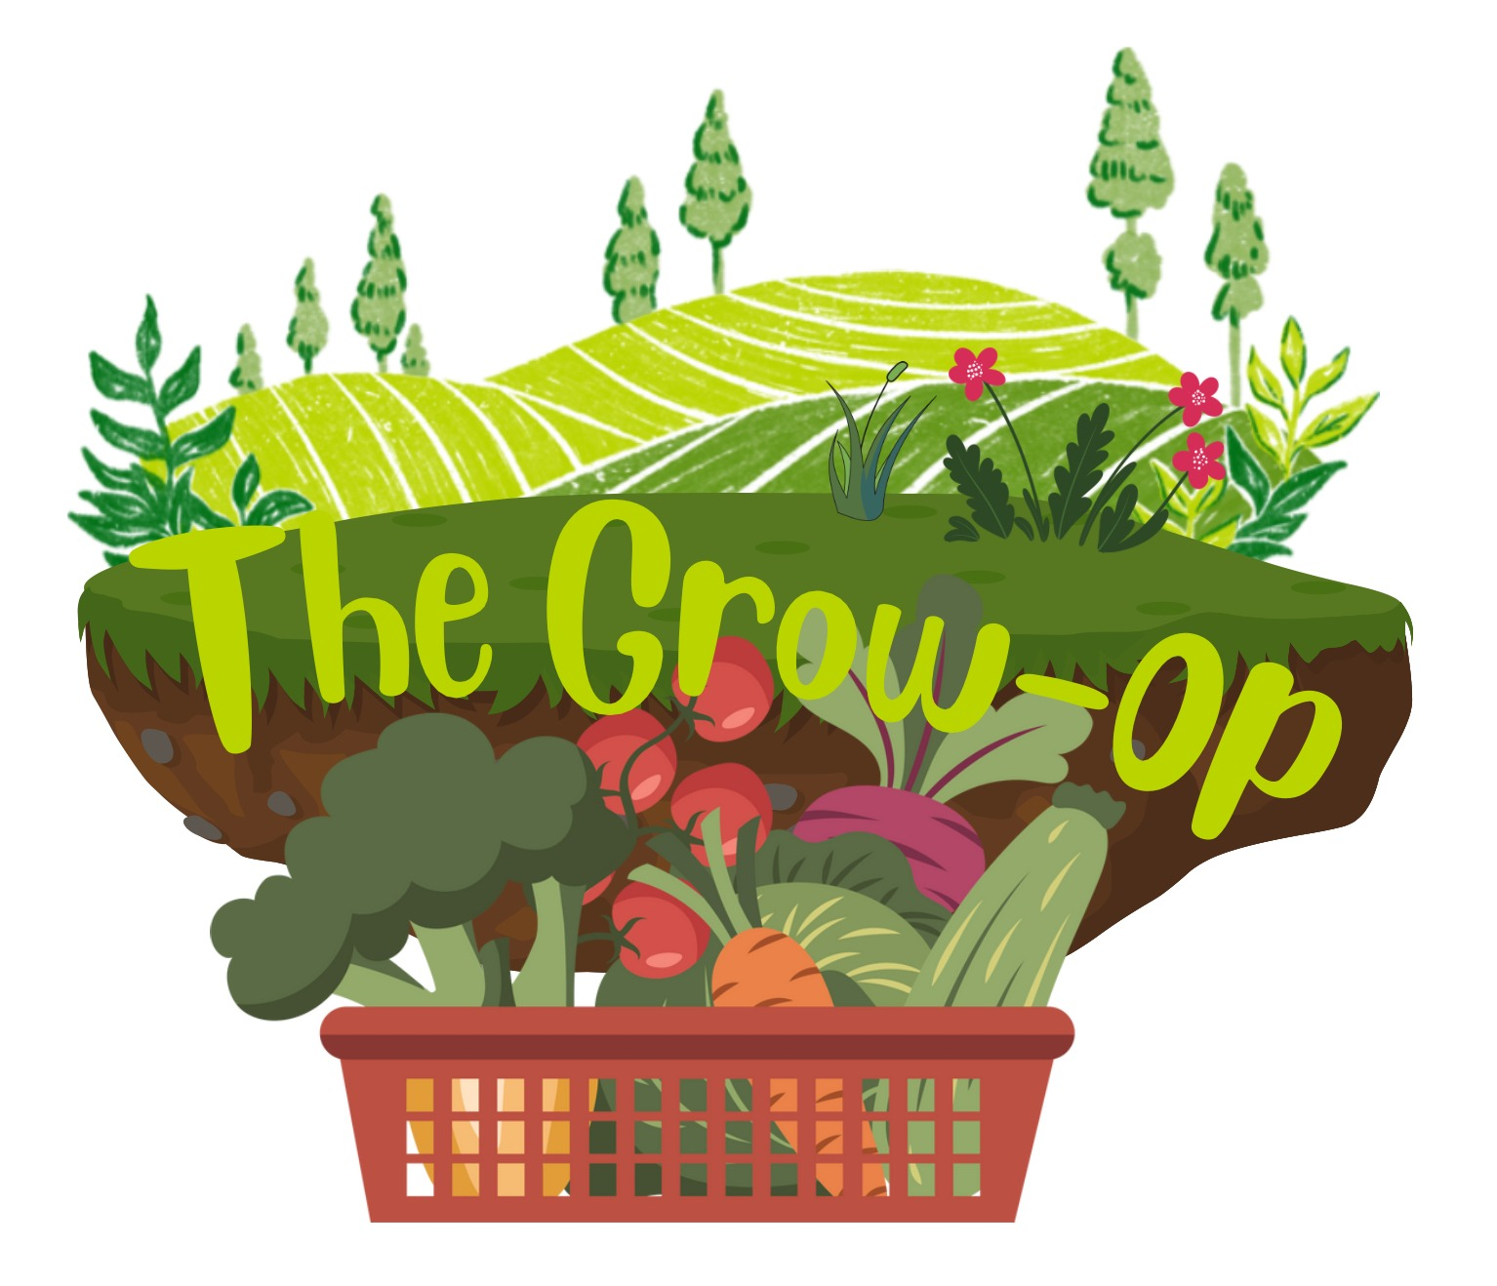
WRIT 3029: Business and Professional Writing
White Paper Draft
Team: Urban Farming
Members: Kaeli, Emily, Kirsten

Copyright © 2026
Table of Contents
Executive Summary 7
Who We Are 7
Why We’re Here 7
What We Do 7
How We Do It 8
Introduction 9
Background, Obstacles, and Response 11
What Is Urban Farming 11
Benefits of Urban Farming 12
Time Investment 12
Problems 15
Food Insecurity 15
Monocropping 16
Communication & Media 19
In-Person Education 19
Media 19
Headquarters 21
Facilities 21
Fresh Market 21
Volunteers 22
Key Partnerships and Funding Streams 23
Grants 23
Donations 23
Partnerships 24
Solution 25
Types of Grow Kits 25
Light Availability 25
Space Availability 26
Time of Year 26
Anatomy of a Grow Kit 27
Planter 27
Soil and Compost Mix 27
Seeds 28
Grow Guide 28
Distribution and Community 29
Conclusion 31
Citations 33

Executive Summary

Who We Are
We’re the Grow-Op, a Twin Cities-based nonprofit introducing people to urban farming, whilst increasing access to fresh produce.

Why We’re Here
Food insecurity is a glaring concern in many urban areas. Across the country, 7.2 million households struggle to afford food. Lack of access to healthy foods contributes to lifelong health problems and systemic inequality. Meanwhile, monocrop cultivation by large corporate farms threatens biodiversity along with the diversity of foods that we eat.

What We Do
Urban farming is extremely small-scale agriculture that can be conducted nearly anywhere, from balconies to rooftops and even apartment windows. It’s often more profitable and less climate-intensive than traditional large-scale agriculture. It can greatly improve food security in communities. Moreover, when we rely on each other instead of on corporations and factory farms, we build stronger, more resilient communities.
We at The Grow-Op introduce people to urban farming by setting them up for success. Many people shy away from growing food because they aren’t good with plants, or don’t have the resources or know-how to get started. We distribute Grow Kits that include
everything needed to start growing food in your own apartment. The kits are customized for a wide variety of light levels, space considerations, and other factors. Each kit includes a Grow Guide outlining every step of the growing process, taking the guesswork out of gardening.

How We Do It
We have a small year-round staff, but much of our work is done by volunteers. We use a three-pronged approach to funding, relying on government grants, donations from individuals and local businesses, and partnerships with other nonprofits and mutual aid networks.
At our headquarters, we grow food for our community, collect and distribute donated produce from local gardeners, offer free community classes on cooking and gardening, and build Grow Kits. We keep in contact with our community through our quarterly digest, our Instagram, and our website.

Introduction
People living in urban environments increasingly face barriers to accessing fresh fruits and vegetables, which is why the ‘Grow-op’ nonprofit organization was formed. We would help people grow their own food by introducing them to the fundamentals of a practical, community-centered approach to urban farming. By identifying challenges that make it difficult for beginners to go all the way from seed to harvest, we can create effective ways to make it accessible, affordable, and feasible even in the tiniest of places.
Our Grow-Op is an urban farming nonprofit organization dedicated to providing fresh produce back into the hands of our community. We are built on the idea that good food doesn’t need to come from a grocery store, by empowering our community members to grow their own produce through our free, beginner-friendly Grow Kits.

Background, Obstacles, and Response
Urban Farming: What Is It and How Does It Work?

What Is Urban Farming
Urban farming is the idea of producing food on a small to large scale within city environments. It can be conducted anywhere, from rooftops, balconies, and windowsills to shared courtyards, community land, and vacant lots. Thanks to recent surveys of European and U.S. residents, we know that most urban farmers are beginners, with limited space, resources, and time to produce on a large scale. These are the exact conditions within communities that encouraged the creation of our Grow-Op services. Jansma et al. (2024) classify those models and identify them as “zero-acreage farms”— dispersed, small-footprint sites connected directly to residential life. Our project closely aligns with that model by functioning as a network of zero-acreage farms supported by education and shared resources.
Additionally, urban farming may include rooftop beds and vertical farm systems, which researchers highlight as promising; however, they are technically challenging due to weight limitations, irrigation requirements, and micro-climate variability (Harada & Whitlow, 2026). These insights help to reinforce our brand of beginner-friendly, container-based, small-scale approach that works best in apartments or small outdoor spaces.

Benefits of Urban Farming
Multiple studies have consistently shown that urban farming increases the availability of fresh produce and improves food security for those within urban environments. Chicago’s farm-anchored produce-prescription initiative (Fruin et al., 2024) shows a measurable increase in benefits for residents monitoring food insecurity, obesity, and diabetes.
Another great benefit of urban farming is its ability to strengthen ties and connections within a community. Data from a research project in the U.K. revealed that small urban farms were more profitable per hectare than their larger rural counterparts, relying instead on shared labor, knowledge, and harvests (Nicholls et al., 2023). Community-based designs helped to address inequities in access to land, resources, and beginner-level knowledge (Richardson et al., 2024).

Time Investment
Finally, the big question that scares many people away from trying out urban farming: how much time is needed to be successful? Luckily for many people, urban farming is intentionally designed to work with busy schedules, not against them. Many of the herbs and vegetables in our grow kits require brief, regular care, including regular watering, rotating containers/pots, and occasional fertilizing. Other easy, infrequent tasks include seasonal planting, thinning, and transplanting. McGivney (2024) states that apartment gardening—small-scale growing—fits seamlessly into hectic daily schedules and routines, offering the benefits of
sustainable produce, confidence, and personal well-being. Making it a great investment of your time.

Problems

Food Insecurity
One of the main problems The Grow-Op addresses is food insecurity. This term has been around for generations, describing people who lack safe, proper access to nutritious, fresh foods. About 48 million people in America, with roughly 14 million of those being children, were insecure about their access to food in the past two years (Cowen, L., 2026, March 8). Meaning 48 million people are not getting the nutrients they need to live comfortably, and are concerned about food not lasting until their next payment to buy more.
In 2024, 69% of those who are classified as very low food security by the USDA in 2024 (7.2 million households) had reported not eating due to the lack of affordable food, and 98% reporting that they are worried that their food will run out before being able to purchase more (Rabbitt M.P. et al., 2025). In recent years, the current president of the United States has changed the tariffs, resulting in a 2.7 % increase in grocery prices since 2024, resulting in those of the lower to middle class being hit the hardest when it comes to buying food for themselves (Meyersohn, N.,2025, September 20). People all over America have concerns about access to the one thing that keeps their bodies functioning.

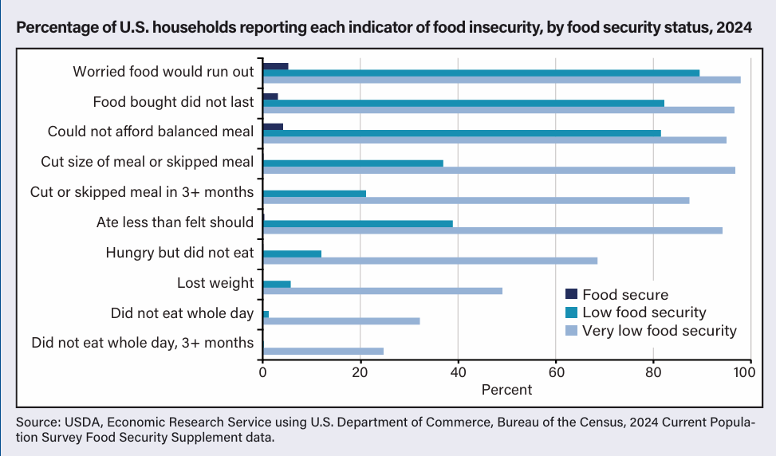
Imports from other countries make up about 60% of America’s fresh fruits and 38% of its fresh vegetables (Meyersohn, N., 2025, September 20). The prices of these goods have only gone up, leaving those in the middle and lower classes with less of the fruits and vegetables they need. Not only is there a concern at the nutritional level, but also at the environmental level.

Monocropping
Second to food insecurity is the environmental impact, specifically monocropping. Monocropping is a form of agriculture that involves a single crop, which, in short, was an attempt to address global hunger by producing crops on a global scale (Robbins, O., 2022 March 18). This resulted in farming the same crop repeatedly, either in the same soil or by rotating it with other mass-produced crops, neither of which was intended by Mother Nature (Robbins, O., 2022 March 18). With this farming technique came a new set of pros and cons;
however, over the years, the cons may have outweighed the pros of this industry.
As the same crop is planted repeatedly, soil quality declines in both fertility and structure, eventually leading to other environmental issues. In more organic farming, different crops allow the soil to recover and retain its natural nutrients. As these acres continue to grow, these crops for mass consumption and the soil lose their nutrients, biodiversity shrinks. Over the last century, crop diversity has declined by 75% due to monocropping (Murugesh, K., 2025 Nov. 25). This uniformity can lead to further issues if a specialized disease were to arise. Take the banana example (Murugesh, K., 2025 Nov. 25): each banana plant shares the same weakness, and when a new disease comes along, it will wipe out these banana plantations.
Which is why at The Grow-Op we prioritize educating people about our current problems to help others understand what our goals and values are. We want people to not only have the access to fresh foods and good nutrients, but also be a part of growing the foods themselves and others while building a community that supports each other.

Communication & Media

In-Person Education
Our free in-person classes are to provide information while building resilient communities. We do this by informing people on the issues that our non-profit aims to better, so they can understand why we are doing what we do and how someone can contribute to not only the bigger problems, but also their community even if they have never done so before.
Classes can focus on anything from pickling vegetables to pesticide-free gardening to advocating for food self-sufficiency networks in your own hometown. Our classes are run by staff and occasional traveling speakers throughout the week. They are here to support those who wish to be a part of our community and support theirs regardless of the level of knowledge that they hold.

Media
Along with our other services the Grow-Op we will send short quarterly digests out to our donors and volunteers. These digests will include things like summarized news, garden articles, planting reminders and updates along with the recipes that we offer to teach in class with the seasonal produce that is grown with our kits. They will also be sent out in both a physical and digital format to reach a wide audience, with the digital being accessible through our website, or on our Instagram account. Both platforms will house information on things like information on the grow kits, the grow guide, a catalog of the seeds and supplies
that we provide, and a place where people can view and sign up for our classes, community events, and workshops that we provide throughout the week.

Headquarters
Our headquarters are at the heart of what we do. Located right in the middle of the Twin Cities, we run a variety of programs here.

Facilities
Inside our building, we have staff offices, storage for compost and materials, classrooms, and our Fresh Market. Our main building and attached greenhouse are situated on a plot of land slightly larger than half an acre. From late March through early November, our grounds are alive with volunteer-tended vegetable gardens and the earthy aroma of fresh compost. A border of native wildflowers and grasses provides welcome color and friendly pollinators. As many of us are familiar with the inhospitability of Minnesota winters, we’ve done our best to keep our gardens going as far into the cold months as possible. Cold frames and mulch let us start lettuce and other leafy greens while there’s snow on the ground in the spring, and keep our late summer and fall crops producing well into November! And our greenhouse is packed with vegetables and potted fruit trees that grow year-round. We use the seeds from our garden and the compost we make to fill our Grow Kits. During the day, our outdoor gardens are open for anyone to stop by.

Fresh Market
Every Thursday from 8 am to 8 pm, we run a market for local families with limited access to fresh produce. All the food is free of charge. We stock the market with produce we grow on-site,
along with donations from Grow Kit recipients and local gardeners. People visiting our market know that the produce they’ll get is locally grown, non-corporate, and free of harmful pesticides and herbicides. All donated produce is washed and inspected before being offered to ensure food safety.

Volunteers
Though we have a small staff, the majority of our work is done through volunteers. Volunteers come to our headquarters to pack Grow Kits, tend to our gardens and compost heap, and run the Fresh Market. We are immensely grateful for the tireless work our volunteers do to keep our dream alive and growing.

Key Partnerships and Funding Streams
Why are they so vital to the growth and continued success of Grow-Op’s Mission?
A sustainable model for our Grow-Op is a blend of grants, donations, and partnerships that align with our mission statement. These three approaches come together to strengthen our core values: sustainability, accessibility, and community enrichment.

Grants
Grants are a pivotal source of support for our Grow-Op, as they fund our Grow Kits, community classes, and overhead costs. Because urban farming has data documenting its benefits, such as improved food access, community revitalization, and its ability to fight climate change, many national and regional funders prioritize these projects and groups (Gattupalli, 2024; Dewey, 2021). They can also ensure the ability to scale, a farming approach supported by nonprofit research that showcases diversified funding and repeatable models, making them key to long-term sustainability (Nonprofit Learning Lab, 2025).

Donations
For our Grow-Op individual donors, local businesses are crucial in helping cover operational costs, such as maintenance and the
distribution of grow kits. It also allows for flexible donations that can be key to testing new ideas, responding to community needs, and addressing emergencies such as severe weather events or climate-driven food price increases. Additionally, it helps community-supported farming models, while small, recurring gifts can stabilize revenue, strengthen resident engagement, allow our nonprofit to expand, and raise awareness of our cause.

Partnerships
Partnerships specifically allow us to expand our reach while also strengthening our distribution network. Urban farms across the U.S. have begun collaborating more with mutual-aid groups, housing organizations, health clinics, and city agencies to help deliver fresh produce and gardening knowledge (Fruin et al., 2024; Gattupalli, 2024). These vital relationships help ensure that food grown through urban farming reaches the homes and communities that need it most. Strengthening community bonds and providing a sustainable alternative to many families who struggle to include fresh produce in their diets and lives.

Solution
Many city-dwellers are interested in food self-sufficiency, but don’t know where to start. That’s where our Grow Kits come in! They simplify urban farming by offering prospective gardeners the resources to get started, no-fuss plant combinations designed to thrive, and the knowledge to build confidence in gardening. We make a wide range of Grow Kits that take into account light levels and space availability.

Types of Grow Kits
Different apartments have different conditions. Apartments with south-facing windows may receive lots of sunshine, while a north-facing apartment will receive none at all. Balconies may offer unparalleled space for tomatoes in the summer, but they can’t be used for gardening at all during a Minnesota winter. Factors like light availability and temperature can make or break urban farming. We want to set gardeners up for success, so we take these factors into account when designing our Grow Kits. Generally, our kits vary in three areas:

Light Availability
Depending on the direction an apartment faces, a window garden could receive anywhere from all-day sun to no sun. To ensure plant success, we offer three light levels:
Low Sun— Designed for north-facing windows and balconies that receive little to no direct sunlight at all. Includes shade-loving
plants such as kale, spinach, mustard greens, chives (which are pretty tolerant of most conditions), and herbs.
Partial Sun— Designed for east- or west-facing windows and balconies that receive direct sunlight for part of the day. Includes a balanced mix of plants such as lettuce, squash, and carrots.
Full Sun— Designed for south-facing windows and balconies that receive direct sunlight for most of the day. Includes sun-loving plants such as radishes, tomatoes, beans, and eggplant.

Space Availability
Balconies offer much more space for gardening than a window. As such, our balcony Grow Kits feature larger planters and account for Minnesota weather.

Time of Year
Many plants in the plant kingdom, especially ones native to Minnesota, coordinate their biological processes to the length of the day. This is why chrysanthemums don’t bloom until fall, or why most Minnesota plants aren’t fooled by a few false springs in February and March. Long day plants flower when the days are long. Short-day plants flower once the days get short enough. For the indoor gardener, this can be confusing and frustrating. Some plants like radishes and tomatoes need to flower to produce fruit, while herbs and leafy greens turn bitter and unpalatable once they flower. Growing the wrong plants at the wrong times of year can result in fruitless tomatoes and radishes, or in leafy greens, a process called bolting. Bolting is
when a plant races to flower at the expense of producing leaves, and can significantly truncate harvests.
To address this, we design separate Grow Kits for summer and winter months. In each one, you can expect flowering crops that will flower, and vegetative crops that won’t. Additionally, winter Grow Kits include cooler-weather plants like broccoli and lettuce that can take advantage of a drafty window.

Anatomy of a Grow Kit
Each Grow Kit contains a small assortment of items to help gardeners get started.

Planter
Each window Grow Kit contains one large wooden crate with about 2-3 cubic feet of space. To ensure proper drainage, holes are drilled in the bottom, and the box is lined with a layer of plastic and a layer of burlap (both with holes) to prevent soil from washing out of the planter and to reduce wood rot. The planter, which itself is built from recycled crates and pallets, can be reused for many growing seasons.

Soil and Compost Mix
We make our own compost at the Grow-Op from yard scraps and on-site food waste. When mixed with potting soil, it improves nutrient composition and water retention, offering a fully organic boost to gardening. The soil and compost are pre-mixed to make gardening easier.

Seeds
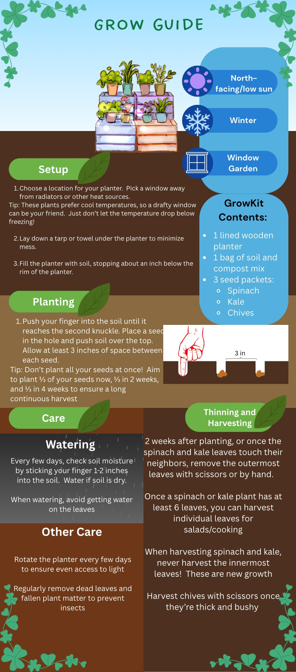
Each Grow Kit contains 2-5 varieties of seeds. The varieties are carefully handpicked to grow in harmony with one another. Tall, stocky plants like corn and sunflowers can provide natural supports to climbing plants like beans. Onions, garlic, and their relatives naturally repel insects and wildlife and can help protect other plants. Squash can shade the roots of beans, allowing them to grow in sunnier locations than normal.

Grow Guide
Every Grow Kit includes a Grow Guide (see example). Each Grow Guide is uniquely tailored to the plants in the kit. It includes information on everything from planting, watering, and caring for plants to harvesting.

Distribution and Community
Grow Kits are given out to community members both at our headquarters and distributed to apartment buildings in food-scarce neighborhoods. We do not require or expect gardeners to return produce they have harvested from their Grow Kits. Instead, we encourage gardeners to eat their harvests and share with others in their local community.
However, we do accept donations of fresh produce. Donors needn’t be part of our Grow Kit program; any urban gardener is welcome to bring their food to our table.
Donated produce, along with the produce we grow at our headquarters, is used to stock our weekly Fresh Market, a free produce market for families struggling with food insecurity or lack of access to fresh food. The Fresh Market is open on Thursdays from 8 am to 8 pm.

Conclusion
As the world becomes more populated the concern for a lasting food source continues as the prices of groceries increase all while Industrialized farms continue to alter and harm the diversity of our environment and foods. The Grow-Op provides the education through in-person classes, support with things like our grow guides and the supplies in our grow-kits in hopes to improve the quality of urban farming while building resilient communities that support each other when the going gets rough by sharing and/or donating fresh produce for our markets and communities. We want to give people the right environment they need to start growing, so the world can grow with them.

Citations
Alex, A. R. (2024, January 16). What is urban farming? transforming city spaces into Green Havens - We Grow NYC. We Grow NYC -. https://wegrownyc.org/what-is-urban-farming/?gad_source=1&gad_campaignid=23300765210&gbraid=0AAAABAWASkvK3xc76NMOlf6EwnyYnjW4Z&gclid=CjwKCAjwyYPOBhBxEiwAgpT8P13bVoB1zx5P3zqCuJYsTNnKLvssCoqAzkkAJaMtn6XdWS_nA5NyshoCy7sQAvD_BwE
Cowen, L. (2026, March 8). The Persistence of Hunger in America. CBS News Sunday Morning. https://www.cbsnews.com/news/the-persistence-of-hunger-in-america/
Dewey, S. (2021, December 23). Urban Agriculture in Our Communities. Conservation Law Foundation. https://www.clf.org/blog/the-power-of-urban-agriculture-in-transforming-a-community/
Fruin, K. M., Tung, E. L., Franczyk, J. M., & Detmer, W. M. (2024). An Urban Farm–Anchored Produce Prescription Program — Food as Medicine and Economic Justice. The New England Journal of Medicine, 391(8), 678–679. https://doi.org/10.1056/NEJMp2407166
Gattupalli, A. (2024, January 16). Urban Agriculture in the United States: Revitalizing neighborhoods. ArchDaily. https://www.archdaily.com/1012190/urban-agriculture-in-the-united-states-revitalizing-neighborhoods
Harada, Y., & Whitlow, T. H. (2026, March 23). Urban Rooftop Agriculture: Challenges to science and Practice. Frontiers.
https://www.frontiersin.org/journals/sustainable-food-systems/articles/10.3389/fsufs.2020.00076/full
Jansma, J. E., Veen, E. J., & Müller, D. (2024). Beyond urban farm and community garden, a new typology of urban and peri‐urban agriculture in Europe. Urban Agriculture & Regional Food Systems, 9(1), Article e20056. https://doi.org/10.1002/uar2.20056
Lab, N. L. (2025, March 11). Different Strategies to Scale Nonprofit Programs: How to Expand Programs for Impact & Secure & Generate Revenue. Nonprofit Learning Lab. https://www.nonprofitlearninglab.org/post/different-strategies-to-scale-nonprofit-programs
McGivney, J. T. (2024, August 19). She’s bringing agriculture to apartment living. Charlotte Magazine. https://www.charlottemagazine.com/shes-bringing-agriculture-to-apartment-living/
Meyersohn, N. (2025, September 20). Trump’s tariffs, deportations and climate change are making groceries more expensive | CNN business. CNN. https://www.cnn.com/2025/09/20/business/grocery-store-prices-kroger-coupons?cid=ios_app
Murugesh, K. (2025, November 25). One crop to rule them all? The hidden dangers of monoculture farming. Earth Day. https://www.earthday.org/one-crop-to-rule-them-all-the-hidden-dangers-of-monoculture-farming/
Nicholls, E., Griffiths‐Lee, J., Basu, P., Chatterjee, S., & Goulson, D. (2023). Crop–pollinator interactions in urban and
peri‐urban farms in the United Kingdom. Plants, People, Planet, 5(5), 759–775. https://doi.org/10.1002/ppp3.10376
Rabbitt, M.P., Reed-Jones, M., Hales, L.J., Suttles, S., & Burke, M.P. (2025). Household food security in the United States in 2024 (Report No. ERR-358). U.S. Department of Agriculture, Economic Research Service. https://ers.usda.gov/sites/default/files/_laserfiche/publications/113623/ERR-358.pdf?v=88107
Richardson, M. L., Taylor, J. R., Thompson, M. J., Rangarajan, A., Mamatha Hanumappa, & Little, N. G. (2024). A profile of urban agricultural growers, organizations, their needs, and challenges in the Northeastern United States. PloS One, 19(4), e0298831–e0298831. https://doi.org/10.1371/journal.pone.0298831
Robbins, O.,(2022, March 18). Monocropping: A disastrous agricultural system. Food Revolution Network. https://foodrevolution.org/blog/monocropping-monoculture/

